**Experiment No.-3**

**Process and Network Management Commands.**

**1. ps/ps-e -Shows All Active User and System Processes.**

**The ps (i.e., process status) command is used to provide information about the currently running processes, including their process identification numbers (PIDs). A process, also referred to as a task, is an executing (i.e., running) instance of a program. Every process is assigned a unique PID by the system.**

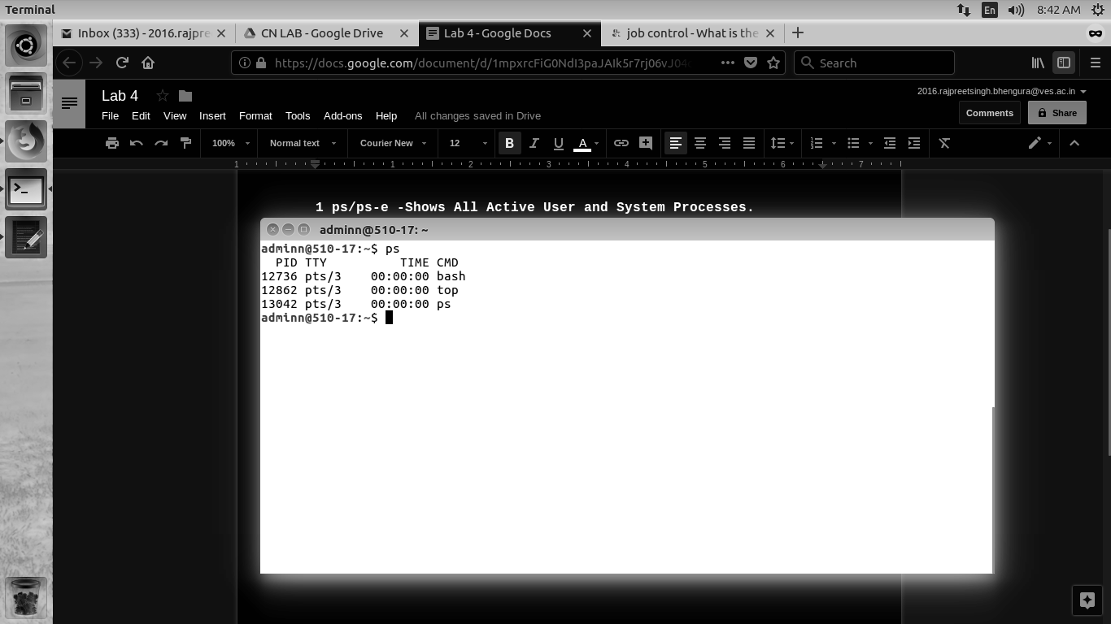

**2. ps -a -Shows All Active User Processes.**

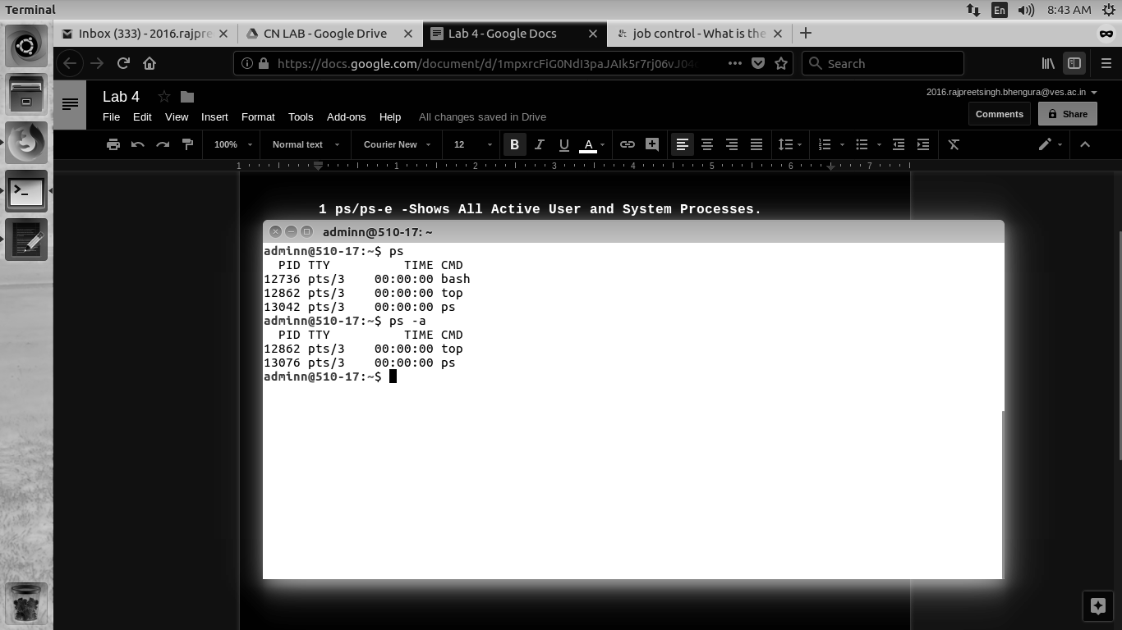

**3. ps -f -Shows All listing Processes**



**4. ps -t -Select all processes associated with this terminal.**

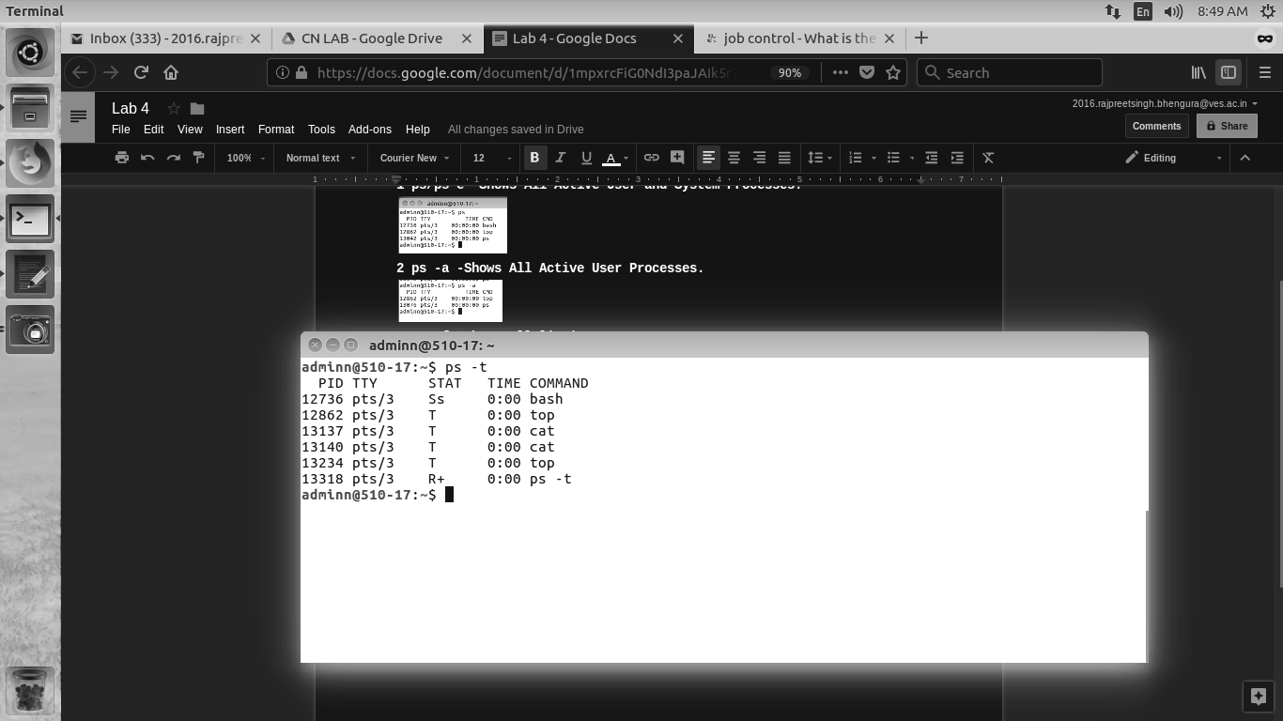

**5.pstree -all running processes in hierarchical manner.**

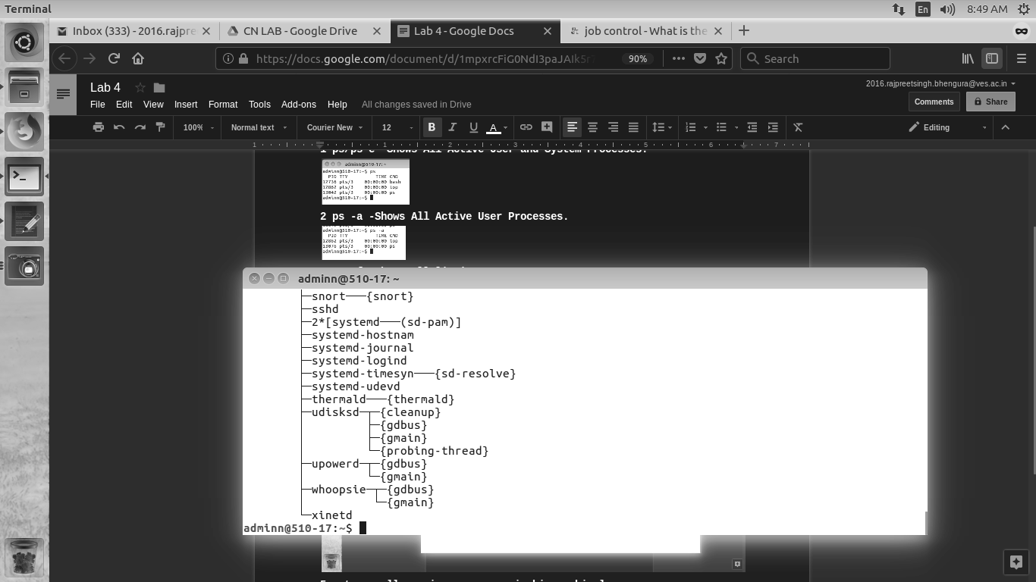

**6.top-all running processes in tabular form manner.**

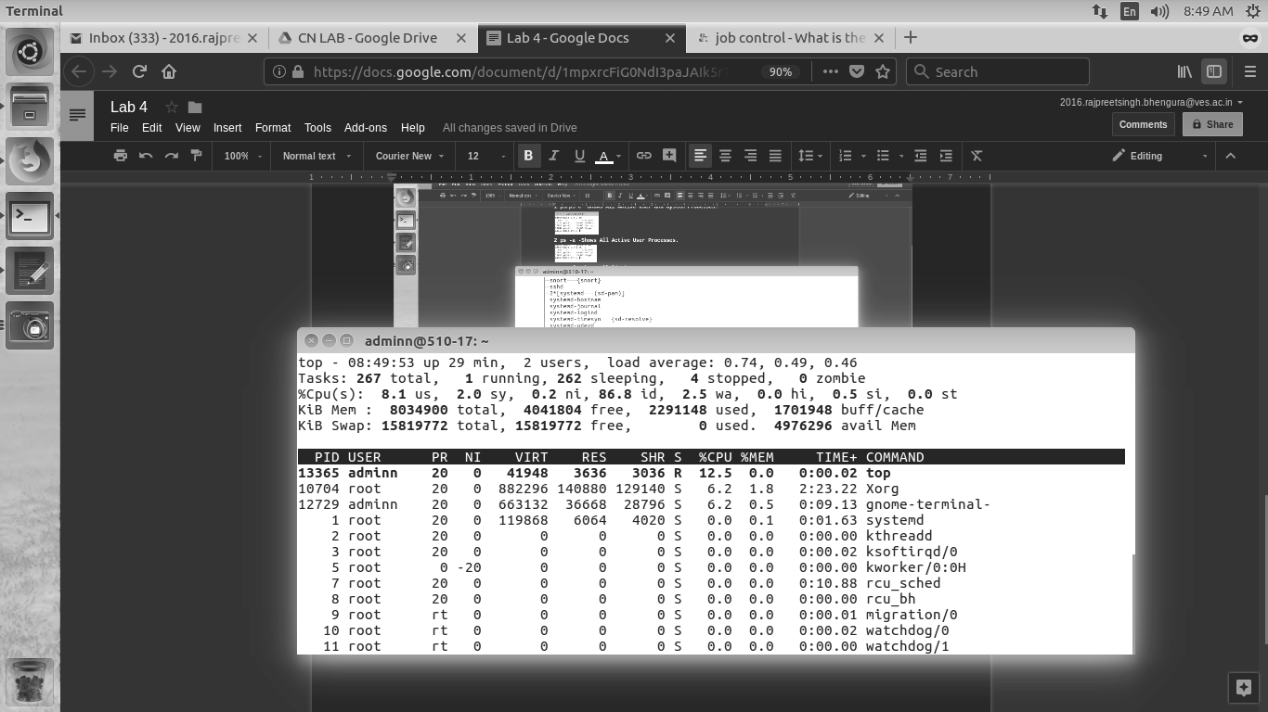

**7.jobs-process running at background with status suspended.**

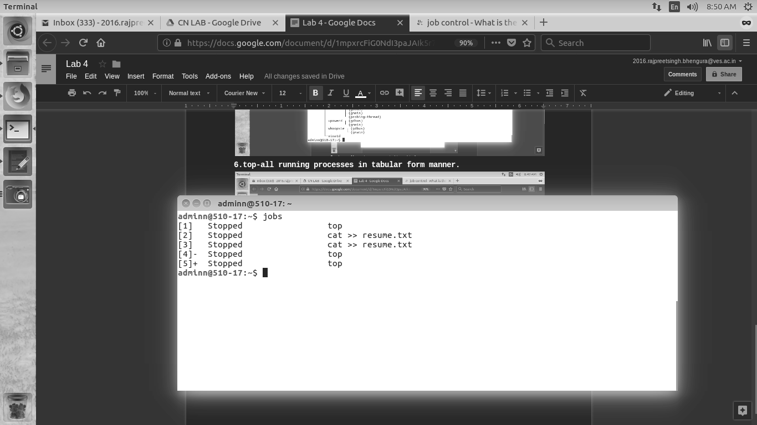

**8. Bg-id :brings job in background**

**9. Fg-id: brings job in foreground.**

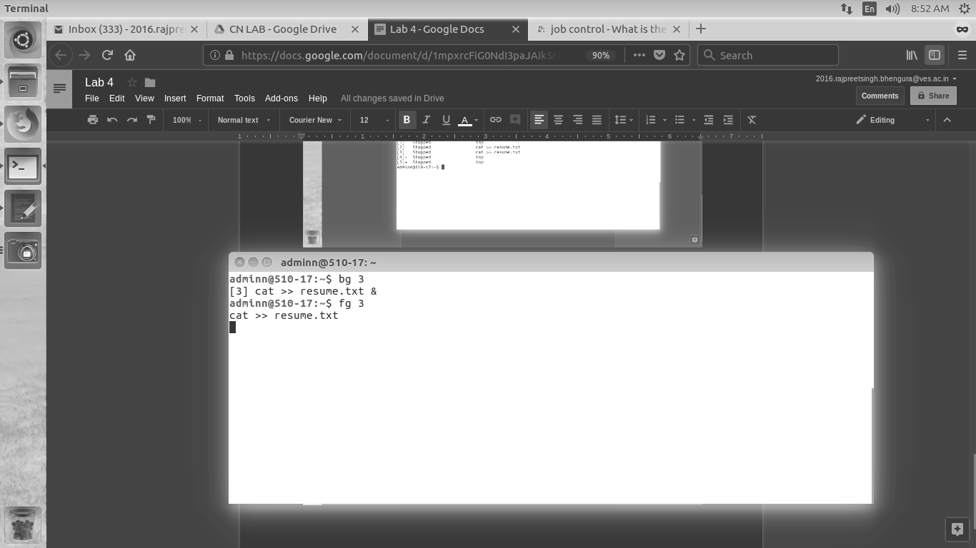

**Jobs -p : gives process id**



**Jobs -l : does long listing of the jobs**

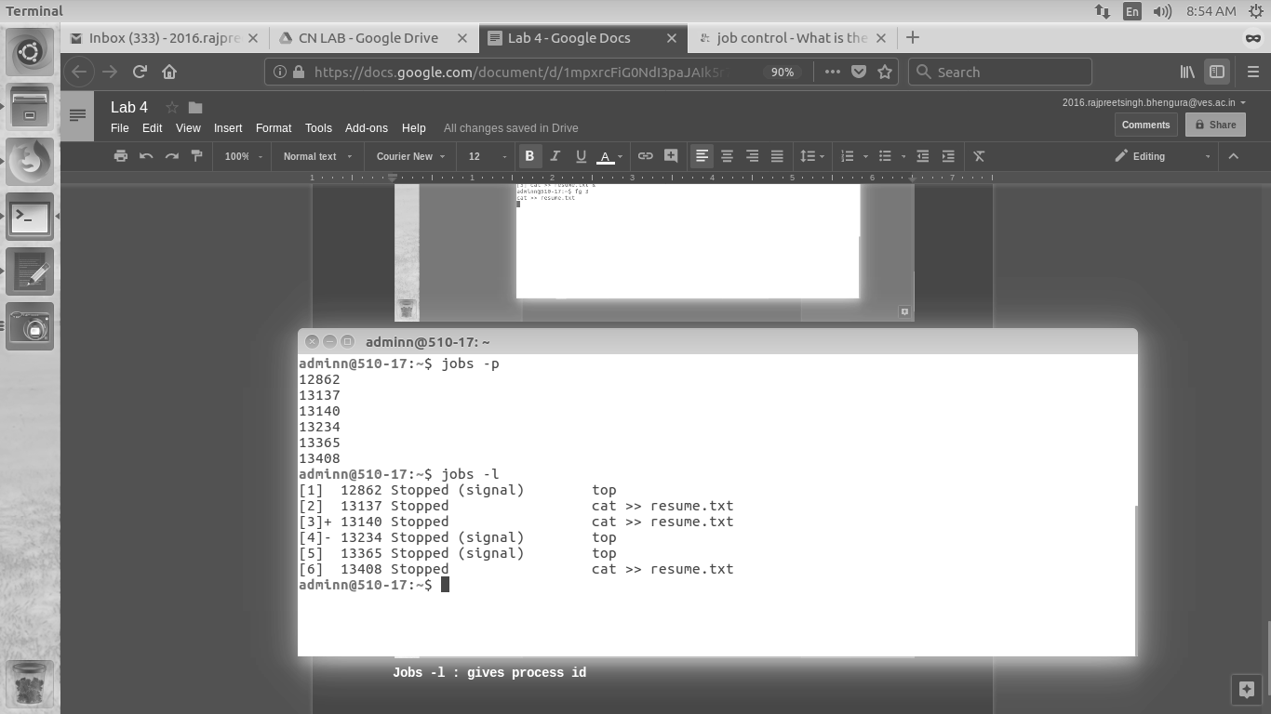

**Kill -9 id: kills a job forcefully.**

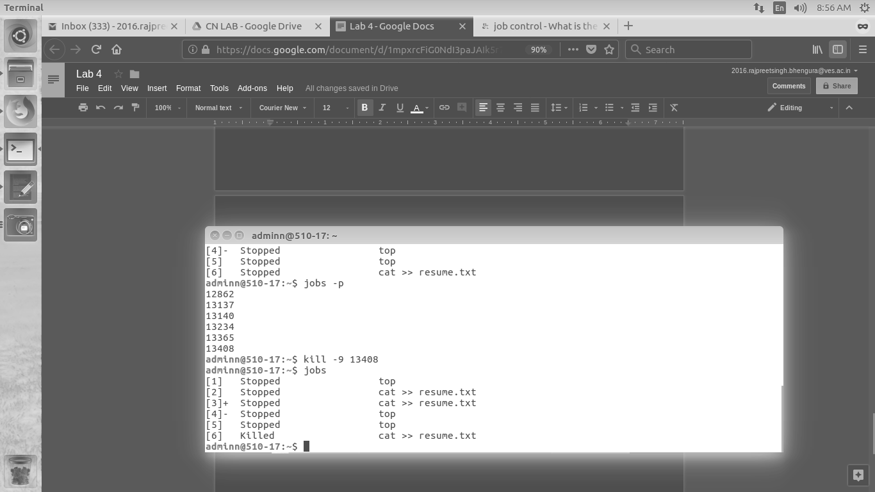

**Nslookup**

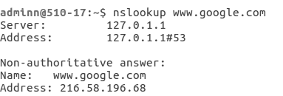

**Ifconfig**

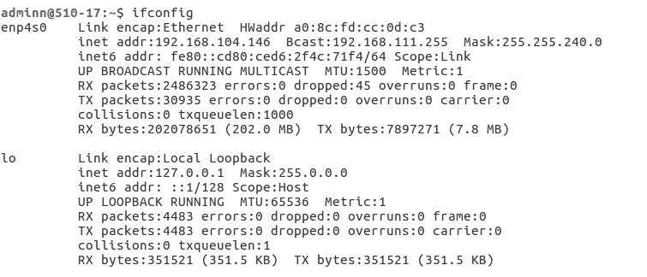

Arp-Address Resolution Protocol:-Matches Ip address to MAC address of all connections.

**arp** with no mode specifier will print the current content of the table. It is possible to limit the number of entries printed, by specifying an hardware address 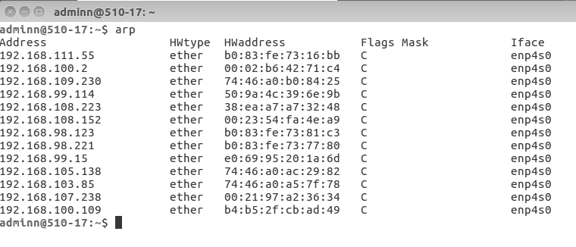type, interface name or host address.

Rarp:Reverse of arp

